UNIT **I Psychology’s History and**

**Approaches**



**MODULES**

1. **Psychology and Its History**
2. **Today’s Psychology and Its Approaches**
3. **Subfields in Psychology**

From news and popular media portrayals, you might think that psychologists analyze personality, offer counseling, dispense childraising advice, examine crime scenes, and testify in court. Do they?

*Yes,* and much more. Consider some of psychology’s questions that you may wonder about:

Have you ever found yourself reacting to something as one of your biological parents would—perhaps in a way you vowed you never would—and then wondered how much of your personality you inherited? *To what extent do genes predispose our individual differences in personality? How do home and community environments shape us?*

Have you ever worried about how to act among people of a different culture, race, gender identity, or sexual orientation? *In what ways are we alike as members of the human family? How do we differ?*

Have you ever awakened from a nightmare and wondered why you had such a crazy dream? *Why do we dream?*  Have you ever played peekaboo with a 6-month-old and wondered why the baby finds your disappearing/reappearing act so delightful? *What do babies actually perceive and think?*  Have you ever wondered what enables school and work success? *Does inborn intelligence explain why some people get richer, think more creatively, or relate more sensitively? Or does gritty effort, and a belief that we can grow smarter, matter more?*  Have you ever become depressed or anxious and wondered whether you’ll ever feel “normal”? *What triggers our bad moods —and our good ones? What’s the line between a normal mood swing and a psychological disorder?*

Psychology is a science that seeks to answer such questions about us all—how and why we think, feel, and act as we do.

 **Unit I Overview Video**

# Module 1 Psychology and Its History

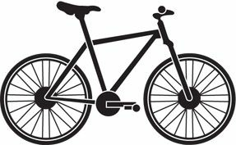

|  |
| --- |
| **LEARNING TARGETS**   * **1–1 Explain how psychology is a science and why the “rat is always right.”** * **1–2 Describe the three key elements of the scientific attitude and how they support scientific inquiry.** * **1–3 Explain how critical thinking feeds a scientific attitude, and smarter thinking for everyday life.** * **1–4 Describe how psychology developed from early understandings of mind and body to the beginnings of modern science.** * **1–5 Describe some important milestones in psychology’s early development.** * **1–6 Explain how behaviorism, Freudian psychology, and humanistic psychology furthered the development of psychological science.** |

Once upon a time, on a planet in our neighborhood of the universe, there came to be people. Soon thereafter, these creatures became intensely interested in themselves and in one another: “Who are we? What produces our thoughts? Our feelings? Our actions? And how are we to understand and manage those around us?”



**A smile is a smile the world around** The science of psychology builds from the input of multiple disciplines in many lands. As you will see throughout this book, we’ve come to learn not only of our cultural and gender diversity but also of the similarities that define our shared human nature. People in different cultures vary in when and how often they smile, for example, but a naturally happy smile *means* the same thing anywhere in the world.

## Psychology Is a Science

|  |
| --- |
| **1-1 How is psychology a science, and why is it the “rat is always right”?** |

Underlying all science is, first, a passion to explore and understand without misleading or being misled. Some questions *(Is there life after death?)* are beyond science. Answering them in any way requires a leap of faith. With many other ideas *(Can some people demonstrate ESP?),* the proof is in the pudding. Let the facts speak for themselves.

**AP**

**®**

**EXAM TIP**



To assist your active learning of psychology, Learning Targets are grouped

together at the start of each module and then framed as questions that appear at

the beginning of the pertinent section of reading. It helps to keep the question in

mind as you read through a section to make sure that you are following the main

point of the discussion.

Magician James Randi has used a scientific *approach* when testing those claiming to see glowing auras around people’s bodies:

**Randi:** Do you see an aura around my head?

**Aura seer:** Yes, indeed.

**Randi:** Can you still see the aura if I put this magazine in front of my face?

**Aura seer:** Of course.

**Randi:** Then if I were to step behind a wall barely taller than I am, you could determine my location from the aura visible above my head, right?

Randi once told me [DM] that no aura seer had agreed to take this simple test.

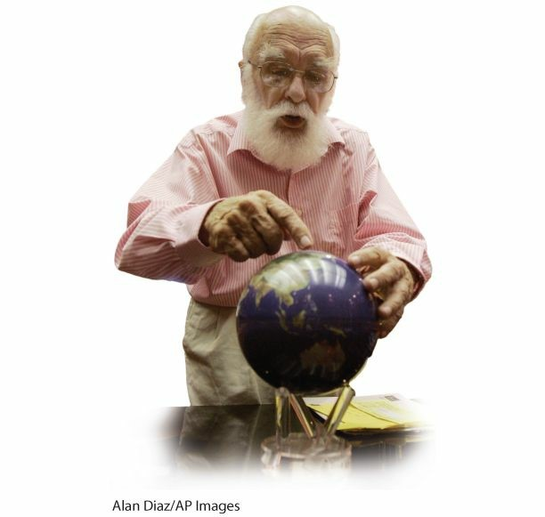

**The Amazing Randi** The magician James Randi exemplifies skepticism. He has tested and debunked supposed psychic phenomena.

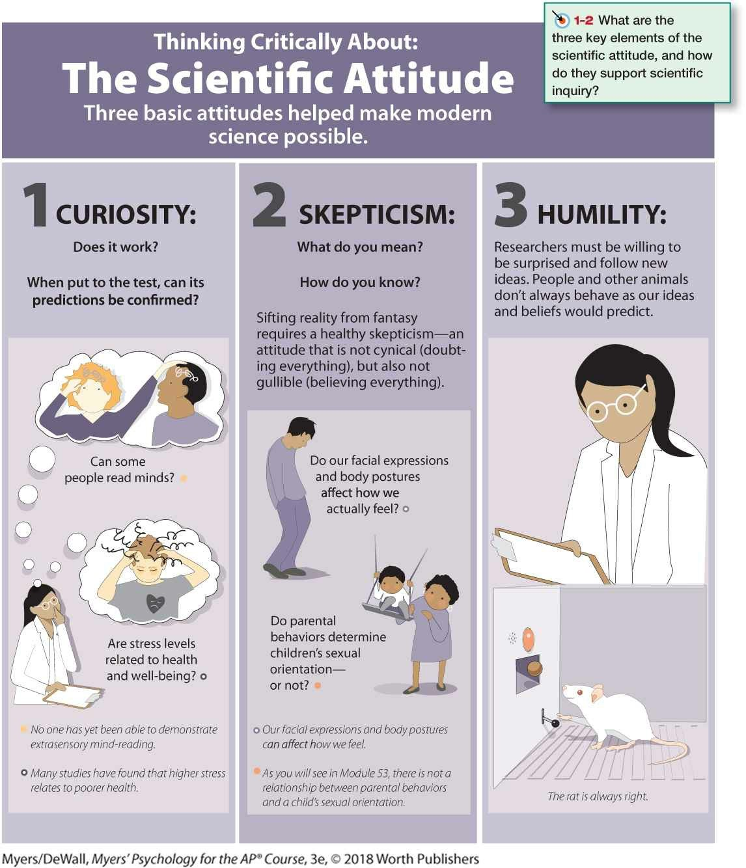

No matter how sensible-seeming or how wild an idea, the smart thinker asks: *Does it work?* When put to the test, do the data support its predictions? Subjected to such scrutiny, crazy-sounding ideas sometimes find support. During the 1700s, scientists scoffed at the notion that meteorites had extraterrestrial origins. When two Yale scientists challenged the conventional opinion, Thomas Jefferson reportedly jeered, “Gentlemen, I would rather believe that those two Yankee professors would lie than to believe that stones fell from Heaven.” Sometimes scientific inquiry turns jeers into cheers.

More often, science becomes society’s garbage disposal, sending crazy-sounding ideas to the waste heap, atop previous claims of perpetual motion machines, miracle cancer cures, and out-of-body travels into centuries past. To sift reality from fantasy, sense from nonsense, verified facts from fake news, therefore requires a scientific attitude: being skeptical but not cynical, open but not gullible. When ideas compete, careful testing can reveal which ones best match the facts. Can astrologers predict your future based on the planets’ position at your birth? Is electroconvulsive therapy (delivering an electric shock to the brain) an effective treatment for severe depression? As we will see, putting such claims to the test has led psychological scientists to answer *No* to the first question and *Yes* to the second.

Putting a scientific attitude into practice requires not only curiosity and skepticism but also humility—an awareness of our own vulnerability to error and an openness to new perspectives. What matters is not my opinion or yours, but the truths revealed by our questioning and testing. If people or other animals don’t behave as our ideas predict, then so much the worse for our ideas. This humble attitude was expressed in one of psychology’s early mottos: “The rat is always right.” (See Thinking Critically About:

The Scientific Attitude.)

## Critical Thinking

|  |
| --- |
| **1-3 How does critical thinking feed a scientific attitude, and smarter thinking for everyday life?** |

The scientific attitude—curiosity + skepticism + humility—prepares us to think harder and smarter. This thinking style, called **critical thinking,** examines assumptions, appraises the source, discerns hidden biases, evaluates evidence, and assesses conclusions. Whether reading a research report or an online opinion, or listening to news or a talk show, critical thinkers ask questions: *How do they know that? What is this person’s agenda? Is the conclusion based on anecdote, or on evidence? Does the evidence justify a cause-effect conclusion? What alternative explanations are possible?*

### critical thinking

thinking that does not blindly accept arguments and conclusions. Rather, it examines assumptions, appraises the source, discerns hidden biases, evaluates evidence, and assesses conclusions.

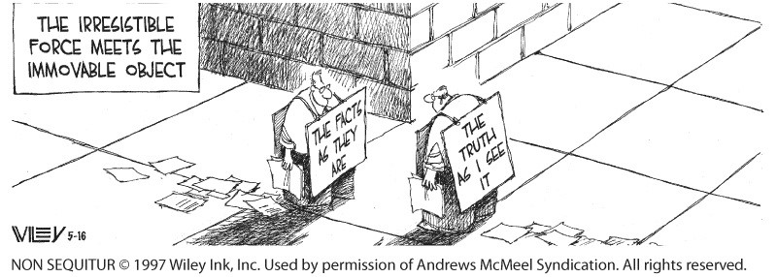

Critical thinkers wince when people make factual claims based on gut intuition: “I *feel like* climate change is [or isn’t] happening.” “I *feel like* self-driving cars are more [or less] dangerous.” “I *feel like* my candidate is more honest.” Such beliefs (commonly mislabeled as feelings) may or may not be true. Critical thinkers are open to the possibility that they might be wrong. Sometimes, they know, the best evidence confirms their intuitions. Sometimes it challenges them and beckons them to a different way of thinking.

## FYI

Throughout the text, important concepts are **boldfaced,** and important people are underlined. As you study, you can find the key terms with their definitions in a nearby margin and in the Glossary/Glosario at the book’s end. (In the e-book, definitions are always a click away.) You will find a list of each unit’s key contributors in the Unit Review and in Appendix C, Psychological Science’s Key Contributors, at the back of the book.

Critical thinking, informed by science, helps clear the colored lenses of our biases. Consider: Does climate change threaten our future, and, if so, is it human-caused? In 2016, climate-action advocates interpreted record Louisiana flooding as evidence of climate change. In 2015, climate-change skeptics perceived North American bitter winter cold as discounting global warming. Rather than having their understanding of climate change swayed by recent weather, critical thinkers say, “Show me the evidence.”

Over time, is the Earth actually warming? Are the polar ice caps melting? Are vegetation patterns changing? And is human activity emitting atmospheric CO2 that would lead us to expect such changes?

When contemplating such issues, critical thinkers will also consider the credibility of sources. They will also look at the evidence *(Do the facts support them, or are they just makin’ stuff up?).* They will recognize multiple perspectives. And they will expose themselves to news sources that challenge their preconceived ideas.

From a tongue-in-cheek Twitter feed: ***“*** *The problem with quotes on the Internet is that you never know if they’re true.****”***

*Abraham Lincoln*

Some religious people may view critical thinking and scientific

inquiry, including psychology’s, as a threat. Yet many of the leaders of the scientific revolution, including Copernicus and Newton, were deeply religious people acting on the idea that “in order to love and honor God, it is necessary to fully appreciate the wonders of his handiwork” (Stark,

2003a,b)

Critical thinking can lead us to surprising findings. Some examples from psychological science: Massive losses of brain tissue early in life may have minimal long-term effects (see Module 12). Within days, newborns can recognize their mother by her odor (see Module 45). After brain damage, a person may be able to learn new skills yet be unaware of such learning (see Modules 31–33). Diverse groups—men and women, old and young, rich and middle class, those with and without disabilities— report roughly comparable levels of personal happiness (see Module 83).

***“*** *My deeply held belief is that if a god anything like the traditional sort exists, our curiosity and intelligence are provided by such a god. We would be unappreciative of those gifts . . . if we suppressed our passion to explore the universe and ourselves.****”***

*Carl Sagan,* Broca’s Brain, *1979*

As later modules illustrate, critical inquiry sometimes also debunks popular presumptions. Sleepwalkers are *not* acting out their dreams (see Module 24). Our past experiences are *not* all recorded verbatim in our brains; with brain stimulation or hypnosis, one *cannot* simply replay and relive long-buried or repressed memories (see Module 33). Most people do *not* suffer from unrealistically low self-esteem, and high self-esteem is *not* all good (see Module 59). Opposites tend *not* to attract (see Module 79). In these instances and many others, what psychological scientists have learned is not what is widely believed.

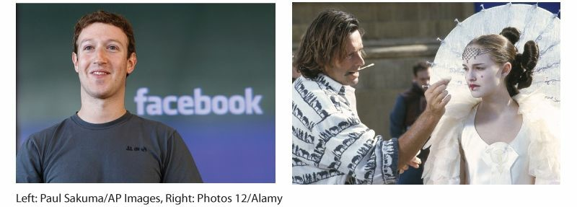

**Life after studying psychology** The study of psychology and its critical thinking strategies have helped prepare people for varied occupations, as illustrated by Facebook founder Mark Zuckerberg (who studied psychology and computer science while at Harvard) and Natalie Portman (who majored in psychology and co-authored a scientific article at Harvard—and on one of her summer breaks was filmed for *Star Wars: Episode I*).

Psychology’s critical inquiry can also identify effective policies. To deter crime, should we invest money in lengthening prison sentences, or increase the likelihood of arrest? To help people recover from a trauma, should counselors help them relive it, or not? To increase voting, should we tell people about the low turnout problem, or emphasize that their peers are voting? What matters is not what we “feel” is true, but what *is* true. When put to critical thinking’s test—and contrary to common practice— the second option in each of this paragraph’s examples wins (Shafir, 2013).

## FYI

Information sources are cited in parentheses, with name and date. Every citation can be found in the end-of-book References, with complete documentation that follows American Psychological Association (APA) style.



**Check Your Understanding**

**Ask Yourself**



Were you surprised to learn that psychology is a science? How would you

defend that point if someone else now asked you about this?

|  |
| --- |
| **Test Yourself**  Describe what’s involved in critical thinking.  *Answers to the Test Yourself questions can be found in Appendix E at the end of the book.* |

### Prescientific Psychology

|  |
| --- |
| **1-4 How did psychology develop from early understandings of mind and body to the beginnings of modern science?** |

To be human is to be curious about ourselves and the world around us. We can trace many of psychology’s current questions back to historic *philosophical* and *physiological* approaches. These early thinkers wondered: How does our mind work? How does our body relate to our mind? How much of what we know comes built in? How much is acquired through experience?

|  |
| --- |
| **AP**  **®**  **EXAM TIP**  Memory research reveals a *testing effect:* We retain information much better if we actively retrieve it by self-testing and rehearsing. (More on this in Module 2.) To bolster your learning and memory, take advantage of the self-testing opportunities you will find throughout this text. These Check Your  Understanding sections will appear periodically throughout each module. The *Ask Yourself* questions will help you relate the material to your life (making it more memorable). You can check your answers to the *Test Yoursel*f review questions in Appendix E. (In the e-book, answers are a click away.) |

In ancient Greece, the philosopher-teacher Socrates (469–399 B.C.E.) and his student Plato (428–348 B.C.E.) concluded that mind is separable from body and continues after the body dies, and that knowledge is innate —born within us. Unlike Socrates and Plato, who derived principles by logic, Plato’s student Aristotle (384–322 B.C.E.) loved data. An intellectual ancestor of today’s scientists, Aristotle derived principles from careful observations. Moreover, he said knowledge is *not* preexisting (sorry, Socrates and Plato); instead it grows from the experiences stored in our memories.

The next 2000 years brought few enduring new insights into human nature, but that changed in the 1600s, when modern science began to flourish. With it came new theories of human behavior and new versions of the ancient debates. A frail but brilliant Frenchman named René Descartes [day-CART] (1595–1650) agreed with Socrates and Plato about the existence of innate ideas and mind’s being “entirely distinct from body” and able to survive its death. Descartes’ concept of mind forced him to wonder, as people have ever since, how the immaterial mind and physical body communicate. A scientist as well as a philosopher, Descartes dissected animals and concluded that the fluid in the brain’s cavities contained “animal spirits.” These spirits, he surmised, flowed from the brain through what we call the nerves (which he thought were hollow) to the muscles, provoking movement. Memories formed as experiences opened pores in the brain into which the animal spirits also flowed.

Descartes was right that nerve paths are important and that they enable reflexes. Yet, genius though he was, and standing upon the knowledge accumulated from 99+ percent of our human history, he hardly had a clue of what today’s average 12-year-old knows. Indeed, most of the scientific story of our self-exploration—the story told in this book—has been written in but the last historical eye-blink of human time. ***“*** *If I see further, it is by standing on the shoulders of giants.****”***

*Isaac Newton, writing to a friend in 1676*

Meanwhile, across the English Channel in Britain, science was taking a more down-to-earth form, centered on experiment, experience, and commonsense judgment. Francis Bacon (1561–1626) became one of the founders of modern science, and his influence lingers in the experiments of today’s psychological science. Bacon also was fascinated by the human mind and its failings. Anticipating what we have come to appreciate about our mind’s hunger to perceive patterns even in random events, he wrote that “the human understanding, from its peculiar nature, easily supposes a greater degree of order and equality in things than it really finds” (*Novum Organuum*, 1620).

Some 50 years after Bacon’s death, John Locke (1632–1704), a British political philosopher, sat down to write a one-page essay on “our own abilities” for an upcoming discussion with friends. After 20 years and hundreds of pages, Locke had completed one of history’s greatest late papers (*An Essay Concerning Human Understanding*). In it he famously argued that the mind at birth is a *tabula rasa—*a “blank slate”—on which experience writes. This idea, adding to Bacon’s ideas, helped form modern **empiricism,** the idea that what we know comes from experience, and that observation and experimentation enable scientific knowledge.

#### empiricism

the idea that knowledge comes from experience, and that observation and experimentation enable scientific knowledge.

### Psychological Science Is Born

|  |
| --- |
| **1-5 What were some important milestones in psychology’s early development?** |

#### Psychology’s First Laboratory

Philosophers’ thinking about thinking continued until the birth of psychology as we know it. That happened on a December day in 1879, in a small, third-floor room at Germany’s University of Leipzig. There, two young men were helping an austere, middle-aged professor, Wilhelm Wundt, create an experimental apparatus. Their machine measured how long it took for people to press a telegraph key after hearing a ball hit a platform (Hunt, 1993). Curiously, people responded in about one-tenth of a second when asked to press the key as soon as the sound occurred—and in about two-tenths of a second when asked to press the key as soon as they were consciously aware of perceiving the sound. (To be aware of one’s awareness takes a little longer.) Wundt was seeking to measure “atoms of the mind”—the fastest and simplest mental processes. So began the first psychological laboratory, staffed by Wundt and by psychology’s first graduate students. (In 1883, Wundt’s American student G. Stanley Hall went on to establish the first formal U.S. psychology laboratory, at

Johns Hopkins University.)

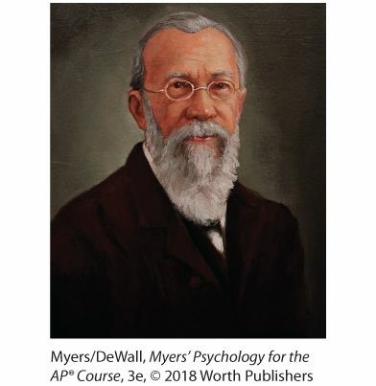

**Wilhelm Wundt (1832–1920)** Wundt established the first psychology laboratory at the University of Leipzig, Germany.

**AP**

**®**

**EXAM TIP**



Every question on the AP

®

Psychology exam will reflect the fact that

psychology is a science built on the tradition of Wundt and his laboratory.

Correct test answers are based on what research has revealed, not on “common

sense”!

#### Psychology’s First Schools of Thought

 **Flip it Video: structuralism vs. Functionalism**

Before long, this new science of psychology became organized into different branches, or schools of thought, each promoted by pioneering thinkers. These early schools included *structuralism, functionalism,* and *behaviorism*, described here (with more on behaviorism in Modules 26–30), and two schools described in later modules: *Gestalt* psychology (Module 19) and *psychoanalysis* (Module 55).

##### Structuralism

Soon after receiving his Ph.D. in 1892, Wundt’s student Edward Bradford Titchener joined the Cornell University faculty and introduced **structuralism.** Much as chemists developed the periodic table to classify chemical elements, Titchener aimed to classify and understand elements of the mind’s structure. He engaged people in self-reflective **introspection** (looking inward), training them to report elements of their experience as they looked at a rose, listened to a metronome, smelled a scent, or tasted a substance. What were their immediate sensations, their images, their feelings? And how did these relate to one another? Alas, structuralism’s technique of introspection proved somewhat unreliable. It required smart, verbal people, and its results varied from person to person and experience to experience. Moreover, we often just don’t know why we feel what we feel and do what we do. Research suggests that people’s recollections frequently err. So do their self-reports about what, for example, has caused them to help or hurt another (Myers, 2002). As introspection waned, so did structuralism.

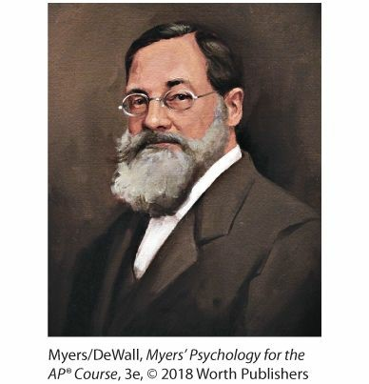

**Edward Bradford Titchener (1867–1927)** Titchener used introspection to search for the mind’s structural elements.

###### structuralism

an early school of thought promoted by Wundt and Titchener; used introspection to reveal the structure of the human mind.

###### introspection

the process of looking inward in an attempt to directly observe one’s own psychological processes.

##### Functionalism

Hoping to assemble the mind’s structure from simple elements was rather like trying to understand a car by examining its disconnected parts. Philosopher-psychologist William James thought it would be more fruitful to consider the evolved functions of our thoughts and feelings. Smelling is what the nose does; thinking is what the brain does. But *why* do the nose and brain do these things? Under the influence of evolutionary theorist Charles Darwin, James assumed that thinking, like smelling, developed because it was *adaptive*—it helped our ancestors survive and reproduce.

Consciousness serves a function. It enables us to consider our past, adjust to our present, and plan our future. As a **functionalist,** James studied down-to-earth emotions, memories, willpower, habits, and moment-tomoment streams of consciousness.

###### functionalism

an early school of thought promoted by James and influenced by Darwin; explored how mental and behavioral processes function—how they enable the organism to adapt, survive, and flourish.

James’ greatest legacy, however, came less from his laboratory than from his Harvard teaching and his writing. When not plagued by ill health and depression, James was an impish, outgoing, and joyous man, who once recalled that “the first lecture on psychology I ever heard was the first I ever gave.” During one of his wise-cracking lectures, a student interrupted and asked him to get serious (Hunt, 1993). He loved his students, his family, and the world of ideas, but he tired of painstaking chores such as proofreading. “Send me no proofs!” he once told an editor. “I will return them unopened and never speak to you again” (Hunt, 1993, p. 145).

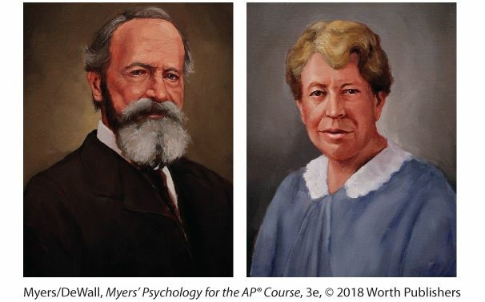

###### William James (1842–1910) and Mary Whiton Calkins (1863–1930)

James was a legendary teacher-writer who authored an important 1890 psychology text. He mentored Calkins, who became a pioneering memory researcher and the first woman to be president of the American Psychological Association.

James’ writings moved the publisher Henry Holt to offer James a contract for a textbook on the new science of psychology. James agreed and began work in 1878, with an apology for requesting two years to finish his writing. The text proved an unexpected chore and actually took him 12 years. (Why are we not surprised?) More than a century later, people still read the resulting *Principles of Psychology* (1890) and marvel at the brilliance and elegance with which James introduced psychology to the educated public.

#### Psychology’s First Women

James’ legacy stems from his Harvard mentoring as well as from his writing. In 1890, thirty years before American women had the right to vote, he admitted Mary Whiton Calkins into his graduate seminar—over the objections of Harvard’s president (Scarborough & Furumoto, 1987). When Calkins joined, the other students (all men) dropped out. So James tutored her alone. Later, she finished all of Harvard’s Ph.D. requirements, outscoring all the male students on the qualifying exams. Alas, Harvard denied her the degree she had earned, offering her instead a degree from Radcliffe College, its undergraduate “sister” school for women. Calkins resisted the unequal treatment and refused the degree. She nevertheless went on to become a distinguished memory researcher and in 1905 became the first female president of the American Psychological Association (APA)—a national organization of professional and academic psychologists.

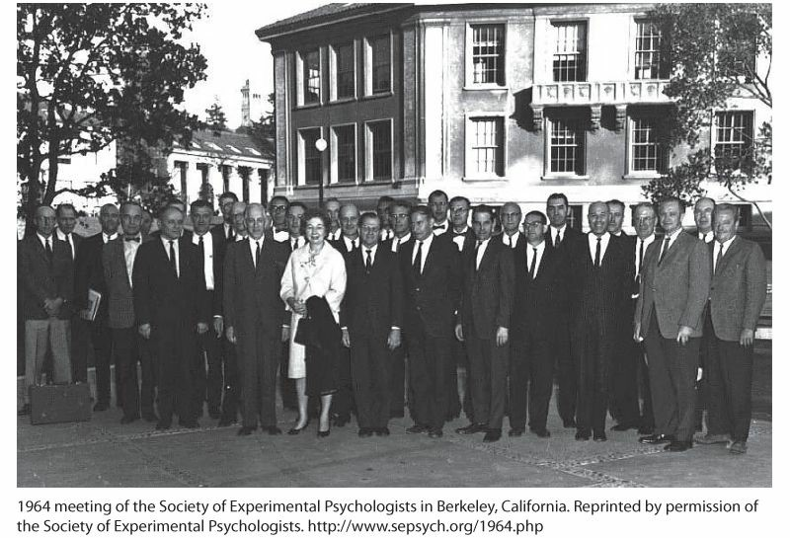

**Formerly male and pale** Over the past half century, psychology has shifted from a mostly white, male discipline to one where women now receive most Ph.D.s. Pioneering female psychologists, such as Inez Beverly Prosser (the first

African-American woman to receive a psychology Ph.D., in 1933) and Eleanor

Gibson (the only woman in this photo from the 1964 Society of Experimental Psychologists—the group that had barred Margaret Floy Washburn), helped pave the way. In 1971, Kenneth Clark became the APA’s first African-American president, and psychology has since then increasingly flourished in diverse communities around the world.

The honor of being the first official female psychology Ph.D. later fell to Margaret Floy Washburn, who also wrote an influential book, *The Animal Mind,* and became the second female APA president in 1921. Her thesis was the first foreign study Wundt published in his psychology journal, but Washburn’s gender barred doors for her, too. She could not join the all-male organization of *experimental psychologists* (who explore behavior and thinking with experiments), despite its being founded by Titchener, her own graduate adviser (Johnson, 1997). What a different world from the recent past—1997 to 2017—when women were 10 of the

20 elected presidents of the science-oriented Association for Psychological Science. In the United States, Canada, and Europe, most psychology doctorates are now earned by women.

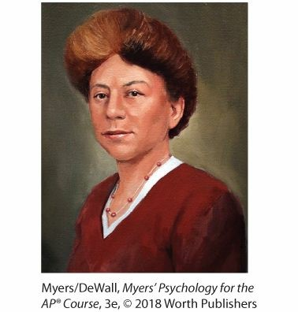

**Margaret Floy Washburn (1871–1939)** The first woman to receive a psychology Ph.D., Washburn synthesized animal behavior research in *The Animal Mind* (1908).

|  |
| --- |
| **Check Your Understanding**  **Ask Yourself**  How do you think psychology might change in the future as more women contribute their ideas to the field?  **Test Yourself**  What event defined the start of modern scientific psychology?  Why did introspection fail as a method for understanding how the mind works?  The school of ______________ used introspection to define the mind’s makeup; ______________ focused on how mental processes enable us to adapt, survive, and flourish.  *Answers to the Test Yourself questions can be found in Appendix E at the end of the book.* |

### Psychological Science Matures

|  |
| --- |
| **1–6 How did behaviorism, Freudian psychology, and humanistic psychology further the development of psychological science?** |

In psychology’s early days, many psychologists shared with the English essayist C. S. Lewis the view that “there is one thing, and only one in the whole universe which we know more about than we could learn from external observation.” That one thing, Lewis said, is ourselves. “We have, so to speak, inside information” (1960, pp. 18–19). Wundt and Titchener focused on inner sensations, images, and feelings. James also engaged in introspective examination of the stream of consciousness and of emotion. For these and other early pioneers, *psychology* was defined as “the science of mental life.”

**AP**

**®**

**EXAM TIP**



There are lots of important people in psychology. As you study, focus on the

significance of their accomplishments. You are more likely to be tested on what

a finding means than who discovered it.

**Behaviorism**

That definition endured until the 1920s, when the first of two provocative

American psychologists appeared on the scene. John B. Watson, and later B. F. Skinner, dismissed introspection and redefined *psychology* as “the scientific study of observable behavior.” After all, they said, science is rooted in observation: What you cannot observe and measure, you cannot scientifically study. You cannot observe a sensation, a feeling, or a thought, but you *can* observe and record people’s *behavior* as they are *conditioned*—as they respond to and learn in different situations. Many agreed, and **behaviorism** was one of two major forces in psychology well into the 1960s.

#### behaviorism

the view that psychology (1) should be an objective science that (2) studies behavior without reference to mental processes. Most psychologists today agree with (1) but not with (2).

#### Freudian (Psychoanalytic) Psychology

The other major force was Sigmund Freud*’s psychoanalytic psychology,* which emphasized the ways our unconscious mind and childhood experiences affect our behavior. (In later modules, we’ll look more closely at Freud’s teachings, including his theory of personality and his views on unconscious sexual conflicts and the mind’s defenses against its own wishes and impulses.)

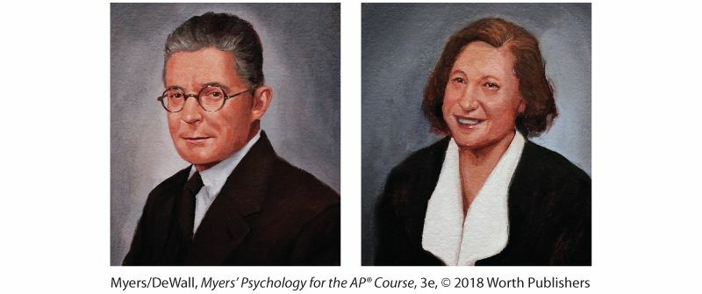

**John B. Watson (1878–1958) and Rosalie Rayner (1898–1935)**

Working with Rayner, Watson championed psychology as the scientific study of behavior. In a controversial study on a baby who became famous as “Little

Albert,” he and Rayner showed that fear could be learned. (More about this in

Module 26.)

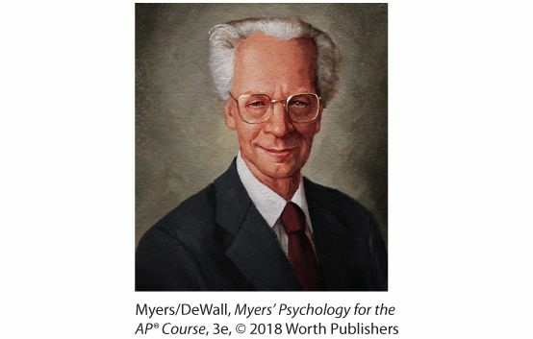

**B. F. Skinner (1904–1990)** This leading behaviorist rejected introspection and studied how consequences shape behavior.

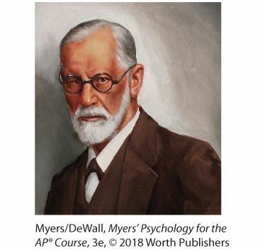

**Sigmund Freud (1856–1939)** The controversial ideas of this famed personality theorist and therapist have influenced humanity’s self-understanding.

#### Humanistic Psychology

As the behaviorists had rejected the early 1900’s definition of *psychology,* other groups rejected the behaviorist definition. In the 1960s, **humanistic psychologists,** led by Carl Rogers and Abraham Maslow, found both behaviorism and Freudian psychology too limiting. Rather than focusing on conditioned responses or childhood memories, the humanistic psychologists focused on our potential for personal growth. (More about the humanistic psychologists in Module 57.)

**humanistic psychology** a historically significant perspective that emphasized human growth potential.



**Check Your Understanding**

**Ask Yourself**



Before this course, how would you have characterized the influence of

Freudian theories in psychology? Would you have placed this influence in a

historical or modern context?

**Test Yourself**



From the 1920s to the 1960s, the two major forces in psychology were

______________ and ______________ psychology.

*Answers to the Test Yourself questions can be found in*

*Appendix E*

*at the end of the book.*

# Module 1 REVIEW

|  |
| --- |
| **1-1 How is psychology a science, and why is it the “rat is always right”?** |

Psychology’s findings are the result of careful observation and testing, and the so-called “rat” (as in a psychologist’s maze, for example) is always right, because the facts are the facts even when we find them surprising.

|  |
| --- |
| **1-2 What are the three key elements of the scientific attitude, and how do they support scientific inquiry?** |

The scientific attitude equips us to be curious, skeptical, and humble in scrutinizing competing ideas or our own observations.

|  |
| --- |
| **1-3 How does critical thinking feed a scientific attitude, and smarter thinking for everyday life?** |

Critical thinking puts ideas to the test by examining assumptions, appraising the source, discerning hidden biases, evaluating evidence, and assessing conclusions.

|  |
| --- |
| **1-4 How did psychology develop from early understandings of mind and body to the beginnings of modern science?** |

The ancient Greeks—Plato and Aristotle—pondered whether mind and body are connected or distinct, and whether human ideas are innate or result from experience.

Descartes and Locke reengaged those ancient debates, with Locke offering his famous description of the mind as a “blank slate” on which experience writes. The ideas of Bacon and Locke contributed to the development of modern *empiricism.*

|  |
| --- |
| **1-5 What were some important milestones in psychology’s early development?** |

Wilhelm Wundt established the first psychological laboratory in 1879 in Germany.

Two early schools of thought in psychology were *structuralism* and *functionalism.*

Structuralism, promoted by Wundt and Titchener, used self-reflection to learn about the mind’s structure. Functionalism, promoted by James, explored how behavior and thinking function.

|  |
| --- |
| **1-6 How did behaviorism, Freudian psychology, and humanistic psychology further the development of psychological science?** |

Early researchers defined *psychology* as “the science of mental life.” In the 1920s, under the influence of John B. Watson and the behaviorists, the field’s focus changed to the “scientific study of observable behavior.” *Behaviorism* became one of psychology’s two major forces well into the 1960s.

The second major force of *Freudian psychology,* along with the influence of *humanistic psychology*, revived interest in the study of mental processes.

## Multiple-Choice Questions1

1. By seeking to measure “atoms of the mind,” who established the first psychology laboratory?
   1. Edward Bradford Titchener
   2. Margaret Floy Washburn
   3. Wilhelm Wundt
   4. G. Stanley Hall
   5. William James
2. Which philosopher proposed that nerve pathways allowed for reflexes?
   1. Socrates
   2. René Descartes
   3. John Locke
   4. Aristotle
   5. Plato
3. Who coined the term *tabula rasa* (blank slate) to help explain the impact experience has on shaping an individual?
   1. Francis Bacon
   2. René Descartes
   3. Edward Bradford Titchener
   4. Mary Whiton Calkins
   5. John Locke
4. Which of the following best describes research typical of Wilhelm Wundt’s first psychology laboratory?
   1. Testing ESP using a wall to observe auras above participants’ head
   2. Using a brain-scanning device to determine the impact events have on brain function
   3. Measuring the reaction time between hearing a sound and pressing a button
   4. Studying helping behavior, based on the premise that people are good
   5. Making careful observations of animal spirits
5. With which of the following statements would John B. Watson most likely agree?
   1. Psychology should study the growth potential in all people.
   2. Psychology should study the unconscious mind.
   3. Psychology should focus on observable behavior.
   4. Psychology should study mental thought processes.
   5. Psychology should study how culture and beliefs impact an individual.

## Practice FRQs

|  |
| --- |
| **1.** Explain why each of the following people were significant in the history of psychology:  William James  Mary Whiton Calkins  Margaret Floy Washburn  **Answer**  ***1 point:*** William James was a key proponent of the functionalist school of thought. He authored the first psychology textbook and courageously mentored Mary Whiton Calkins.  Page 8  ***1 point:*** Mary Whiton Calkins was the first woman to complete the work necessary for a psychology Ph.D. (from Harvard), though she was denied that degree due to her gender. She was a distinguished memory researcher and was the first female president of the American Psychological Association (APA).  Page 8  ***1 point:*** Margaret Floy Washburn earned the first official psychology Ph.D. She wrote an influential book, *The Animal Mind*, and was the  second female president of the APA.  Page 9 |

**2.** Analyze how curiosity, skepticism, and humility enable you to distinguish between gut intuition (feeling like you know something) and the scientific attitude (seeking to verify what you know with evidence).

***(3 points)***

### AP® EXAM TIP

FRQ stands for “Free-Response Question.” The AP® exam contains two of these essay-style questions, which count for one-third of your final score. The actual FRQs will be complex, requiring you to integrate knowledge from across multiple modules, like the practice questions you will find at the end of each



|  |
| --- |
| unit in this text. These simpler “Practice FRQs” that appear at the end of each module, along with a sample grading rubric, will help you get started practicing this skill. |